**Top 10 real money games**

Gaming industry has several variations and genres that make it the most successful industry in the world. Apart from all the pleasure that gaming offers, real money gaming add on to the entertainment and excitement with the earnings they provides. Real money gaming applications are the ones that require skills and concepts to apply on various gaming techniques to win real money anytime with just the accessibility of some applications.

Several real money gaming applications are available across the globe for accessibility in Android and IOS devices. Many of the games are freemium games that have some in-app purchases for enhanced experiences. However, a few real money games charge entry amounts that go on to the entries for various games and the prize money that one receives in these games.

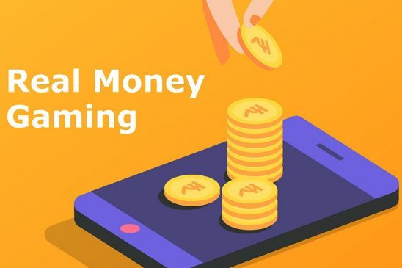

Don’t you also want to earn with just your mobile devices? Do you want to enjoy the games and pass time and meanwhile make money out of every winning?

The top most real money game application that are available for mobile devices requiring some skills and knowledge are as follows:

**SwagBucks**

SwagBucks application has several features and services that are offered to earn real money by various accessibilities. Gaming is one part of the application that can be used as an earning source. The games rewards are termed as ‘swagbucks’, and they are easy used with various e-commerce and retail services like Amazon, Walmart, etc by redeaming the vouchers. The earning that can be made from these games has a limit for each day, and this ensures higher engagement for a longer period.

**Mistplay**

Mistplay has several games that are offered for entertainment and prizes. Gamers can discover the options and earn points with the same. These points can be used on e-commerce websites and applications and other brands to buy the gift cards. There are several gaming genres available to be chosen according to your likes and choices. With perfect entertainment and a few hours of gameplay, one might earn about $5 or more in just a week. This gaming platform is available for the Android users, but there is also a expectation of it getting launched for iOS soon.

**InboxDollars**

To earn more money other than the rewards and the points, InboxDollar is the best platform to have access to. There are several games available with this platform, and the games are paid as well as free with several experiences to earn. This ensures rewards redeem as actual dollars. There are more than 30 free games that adds-on to the excitement and entertainment offered. The earning can be transferred to the bank accounts and the average earning that one might get from each activity is $5.

**Lucktastic**

This is a great gaming application platform that ensures money earning without any payment requirements. This is a free gaming platform and provides a good amount of money earned with up to $10,000 of the prizes. Prize can be redeemed as gift cards, rewards, as well as for the account transfers. There are various prizes available too in the prize-store of the application that can be purchased too from the earned amount.

**Long Game**

Long game is the best platform to have fun and meanwhile earn money to meet your financial requirements. In the beginning, verification is needed to be done and the bank account is linked with the application. The payment for each day is decided with the game application and each time the money is added to the account, the coins are earned that can be used to play the games and earn extra cash prizes. The money that get transferred to the savings account of the application can be later on transferred to the other accounts and has full protection and security to ensure your safe transactions and money deposits.

**Bananatic**

Bananatic is a great application that ensures exciting gameplay experience for the newest game releases, and you are needed to provide the feedback for these gameplay events. This platform is used for the testing purposes by various developers and publishers, and the reviews and suggestions can be used for the improvements of the games. There are several discussion forums available for the games, bugs, and development practice. And, rewards are earned for playing the games and providing the feedbacks.

**Brain Battle**

Brain battle has been providing earnings to several game players across the globe and it has distributed about tens of thousands of dollars already to the players. This game’s publisher provides the rewards by sharing some part of the advertisement revenue. This application does not have any in-app purchases required to win, this is a free application and players can collect the tickets with the games they played. Ticket can be converted into the cash prize. The number of tickets decides the amount of the winning, the higher the numbers of tickets, grand the prize can be. The money is then transferred through the Paypal accounts.

**Lucky day**

Lucky days Casino game provider platform has several Casino games available on the mobile devices including the Slots, Scratch-off, and many more. There are several cash prizes available and daily up to $100,000 can be withdrawn from the winnings. There are several points that can be earned too, and these points can be used to get the gift card from the popular retailers of e-commerce services. Scratch cards are available too that provides the prizes to the lucky winners of the day.

**Big Time Cash**

Big time cash has more than 600 games that provide extreme entertainment with the awards and prizes. There are tickets that are provided with each gameplay event and can be used to draw the cash prizes. Just like the brain battle, it also depends on the criteria of more the tickets, more the chance of winning. This application does not require any in-app purchase or upgrade, and is a free application that adds-on to the advantages. As the number of people joining the application increases, the prize amount also increases. This application is available for both Android and iOS users.

**Blast**

This application has a service that allows winning cash rewards for gameplays and earnings can be saved for various transactions. This is a free application that requires a small verification and account linking to transfer the funds. There are several games that can be used for playing and earning the points, and for every dollar you earn these points. These points help you to mark your position in the leader board and get a chance to win the battle awards and prizes.

**Real money game app development**

Game app studio has a team of expert developers who excel in every niche in the development. We also have expertise in the development of real money games and we enhance the game quality with better features for transaction and wallet handling, proper verifications, and many other features according to different needs and requirements. We also provide 24/7 support for the clients and ensure transparency too.